**Second law of Thermodynamics**

The first law states that when a closed system undergoes a cyclic process, the cyclic integral of the heat is equal to the cyclic integral of the work. It places no restrictions on the direction of the heat and the work.

As no restrictions are imposed on the direction in which the process may proceed, the cycle may be reversed and it will not violate the first law.

**Example (1):**

㤭矪Ꚉ矧(

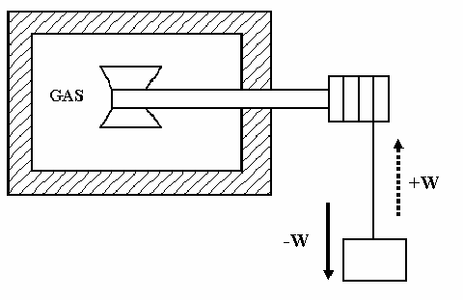

**A closed system that undergoes a cycle involving work and heat.**

In the example considered the system undergoes a cycle in which work is first done on the system by the paddle wheel as the weight is lowered. Then let the cycle be completed by transferring heat to the surrounding.

From experience it has been learnt that we cannot reverse this cycle. i.e., if we transfer heat to the gas, as shown by the dotted line, the temperature of the gas will increase, but the paddle wheel will not turn and lift the weigh. This system can operate in a cycle in which the heat and work transfers are both negative, but it cannot operate in a cycle when both are positive, even though this would not violate the first law.

**Example (2):**

Let two systems, one at a high temperature and the other at a low temperature undergoes a process in which a quantity of heat is transferred from the high – temperature system to the low temperature system. From experience we know that this process can take place. But the reverse process in which heat is transferred from the low temperature system to the high temperature system does not occur and that it is impossible to complete the cycle by heat transfer only.



These two examples lead us to the consideration of the heat engine and heat pump (i.e., refrigerator).

Experience tells us that the reversed processes described above do not happen. The total energy of each system would remain constant in the reversed process and thus there would be no violation of the first law. It follows that there must be some other natural principle in addition to the first law and not deducible from it, which governs the direction in which a process can take place in an isolated system. This principle is the Second law of thermodynamics.

Example (3) **Work of the mechanical form, can be converted completely into heat**

Consider the pushing of a block over a rough surface. The work used in pushing the block to overcome friction produces a heating effect on the block and the surface. To restore the temperature of the system to its original value, heat, equivalent in amount to the work input must be removed from the system. But from experience the converse of the operation is impossible. The heat that was removed will not of its own accord flow back into system, restore the block to its original position and deliver an amount of work equivalent to the original work input. Furthermore, heating the block will obviously not cause it to move, either.

The first law does not answer many questions (1) why there cannot be complete transformation of heat into work but work can be completely transformed into heat. (2) Why some processes can proceed in one direction but not in the other and the first law in no way explain, why it is possible for certain processes to take place but impossible for other processes to occur.

The second law does provide answers to these questions. The second law is broad and the heart of the second law is a property called **Entropy.**

**Heat Engine:**

Any device which converts heat into work. Consider a heat engine as a system which work in a thermodynamic cycle and converts a portion of the heat into the work, when the heat transfer occur from a body at higher temperature to a low temperature body. E.g., steam power plant, Thermocouple etc.

Gas turbines are also called heat engines though they do not work in a thermodynamic cycle

**Steam power plant:**

Let QH = Heat transferred from a high temperature reservoir like a furnace to the working fluid (water)

QL= Heat rejected from the steam to the low temperature reservoir like coolant in the condenser.

W= Amount of work done by the fluid during the cycle to run the generator or any other devices.

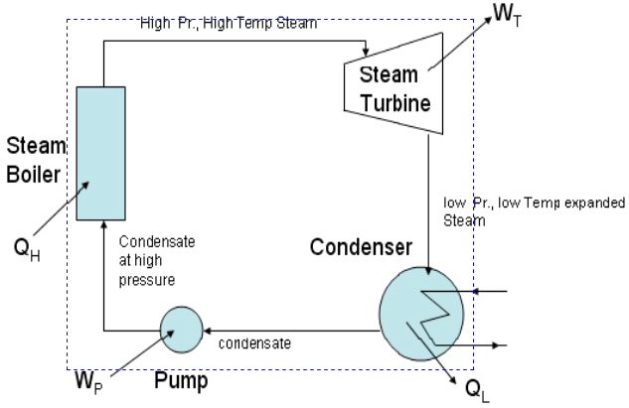

**A steam turbine power plant**

Thermal Efficiency (ηth)





The first law has put no restriction by which the whole heat energy  cannot be converted into work *W*, by reducing the transfer of heat to the low temperature reservoir to zero i.e., by reducing  to zero. The ηth in that case would have 100%. But from experience such performance is impossible. During the process there will always be some loss of energy. This is also one of the limitation of the first law.

**Refrigerator:**



Heat cannot flow from a low temperature body to a high temperature body. But this can be done by providing external work to the system.

Consider a simple vapour compression system.

W Amount of work done on the fluid (Refrigerant)

QL Amount of heat that is transferred to the fluid (Refrigerant) in the evaporator (low temperature reservoir)

QH Heat transferred from the fluid to the coolant in the condenser (High temperature reservoir)

The efficiency of a refrigerator is given by the term COP.

When the system works as refrigerator, the main interest is the net cooling effect  for a refrigerator,





When the system works as a heat pump, the main interest is the heat. Therefore for a heat pump.



This illustration shows the limitation of the first law. From these we conclude that there must be some physical principle which though not derivable from the first law, directs the direction and extent up to which energy can be converted into one form to the other form. This principle is the second law of thermodynamics.

Second law like first law has no mathematical proof. It is based on the results of countless observations in nature.

**PERPETUAL MOTION MACHINE OF FIRST KIND (PMMKI)**

No machine can produce energy without corresponding expenditure of energy without corresponding expenditure of energy i.e., it is impossible to construct a PMMK of first kind. The machine violates the first law of thermodynamics. All attempts made so for to make PMMKI have failed, thus showing the validity of the first law.

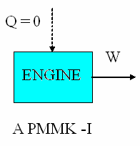

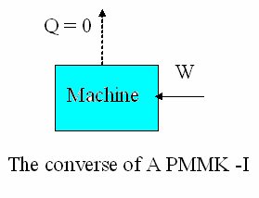

**Second law of Thermodynamics**

There are two classical statements of the second law of thermodynamics

1. Kelvin – Planck statement
2. Clausius statement

**Kelvin – Planck statement**

“It is impossible to construct a device which will operate in a cycle & produce no effect other than the raising of a weight and the exchange of heat with a single reservoir”

i.e., it is impossible to construct an engine which will operate in a cycle will produce no effect other than the transfer of heat from a single thermal reservoir and the performance of an equivalent amount of work”.

No actual or ideal engine operating in cycles can convert into work all the heat supplied to the working substance, it must discharge some heat into a naturally accessible sink because of this aspect and the second law is often referred as the law of degradation of energy.

The statement implies that it is impossible to construct a heat engine that working in a cyclic process can absorb an amount of heat from a high temperature reservoir and can do an equivalent amount of work. In other words it is not possible to construct a heat engine having thermal efficiency of 100 percent.

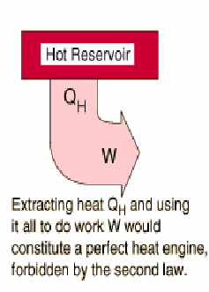

**W**

Steadily operating system

**QH**

Constant Temp

System

 

**A directional implication of the 2nd Law**

**PERPETUAL MOTION MACHINE OF SECOND KIND (PMMKII)**

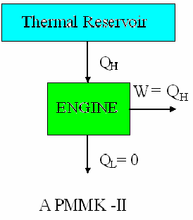

Without violating the first law a machine can be imagined which would continuously absorb heat from a single thermal reservoir and would convert this heat completely into work. The efficiency of such a machine would be 100%. This machine is called PMMK II. A machine of this kind will violate the second law of thermodynamics and hence does not exist.

**Clausius Statement**

It is impossible to construct a heat pump which operating in a cycle will produce no effect other than the transfer of heat from a low temperature thermal reservoir to a higher temperature thermal reservoir.

That is in order to transfer heat from a low temperature thermal reservoir to a high temperature thermal reservoir work must be done on the system by the surroundings.

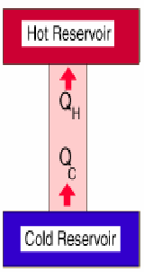

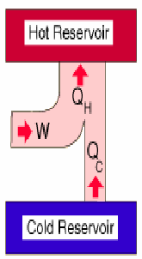



POSSIBLE

Although the Kelvin – Planck and Clausius statements appear to be different, they are really equivalent in the sense that a violation of one statement involves violation of the other.

Although the Kelvin – Planck and Clausius statements appear to be different, they are really equivalent in the sense that a violation of one statement involves violation of the other.

**Proof of violation of the Kelvin – Plank statement results in violation of the Clausius statement.**

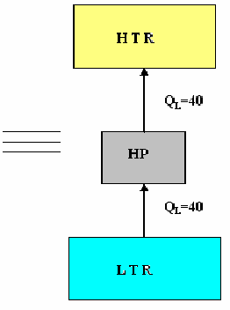

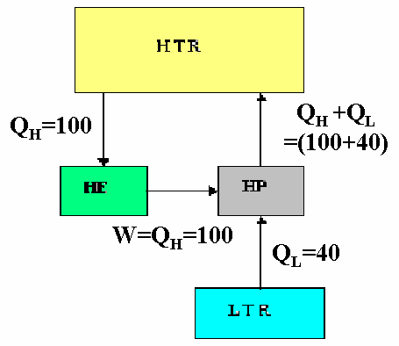

Consider a heat engine that is operating in a cyclic process takes heat (*QH*) from a high temperature reservoir & converts completely into work (*W*), violating the Kelvin – Planck statement.

Let the work W, which is equal to *QH,* be utilized to drive a heat pump as shown. Let the heat pump take in *QL* amount of heat from a low temperature reservoir and pump (*QH + QL)* amount of heat to the high temperature reservoir.

From the diagrams we see that a part of heat *QH*, pumped to the high temperature reservoir is delivered to the heat engine, while there remains a heat flow *QL*, from the low temperature reservoir to the high temperature reservoir, which in fact violates the Clausius statement.

**Proof of violation of the Clausius statement results in violation of the Kelvin – Planck statement.**

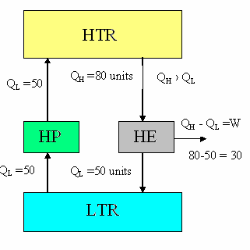

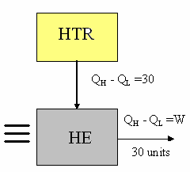

Consider a heat pump that operating in a cyclic process takes in an amount of heat *QL* from LTR and transfer the heat equivalent amount of heat *QL* to the HTR violating the Clausius statement.

Let an amount of heat *QH*, which is greater than *QL*, be transferred from high temperature reservoir to a heat engine, an amount of heat *QL*, be rejected by it to the LTR and an amount of work *W* which is equal to (*QH – QL* ) be done by the heat engine on the surrounding.

Since there is no change in heat transfer in the LTR, the heat pump, the HTR and the heat engine together can be considered as a device which absorbs an amount of heat (*QH – QL*) from the HTR and produce an equal amount of work W = *QH* – *QL* which in fact violates the Kelvin – Planks statement.

**Reversibility and Irreversibility**

If 100% efficiency is unattainable, what is the max possible efficiency which can be attained and what factors promote the attainment of this max value? In trying to answer these questions, thermodynamics has invented & used the concept of reversibility, absolute temperature and entropy.

**Reversible Process:**

-for a system is defined as a process which once having taken place, can be reversed and leaves no change in either the system or surroundings. Only ideal processes can do this and restore both system and surroundings to their initial states. Hence an ideal process must be a reversible process.

No real process is truly reversible but some processes may approach reversibility, to a close approximation.

Example:

1. Frictionless relative motion
2. Extension and compression of a spring
3. Frictionless adiabatic expansion or compression of fluid.
4. Polytropic expansion or compression etc.,

The conditions for a process to be reversible may be given as follows:

1. There should be no friction
2. There should be no heat transfer across finite temperature difference.
3. Both the system and surrounding be stored to original state after the process is reversed.

Any process which is not reversible is irreversible.

Example: Movement of solids with friction, A flow of viscous fluid in pipes and passages mixing of two different substances, A combustion process.

Every quasistatic process is reversible, because a quasistatic process is of an infinite succession of equilibrium states.

**Examples of reversible processes:**

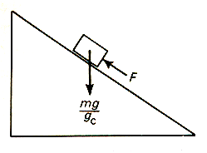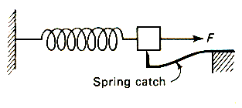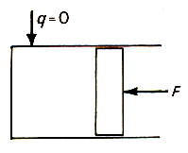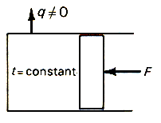

1. Frictionless relative motion
2. Extension of a spring
3. Slow frictionless adiabatic expansion
4. Slow frictionless isothermal compression

**Examples of Irreversible processes:**

(i) Solid Friction (ii) Free expansion

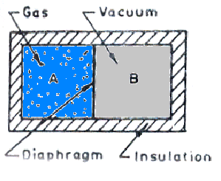

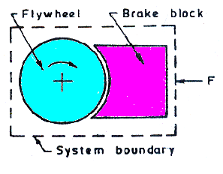



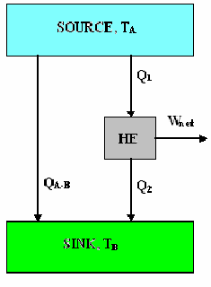

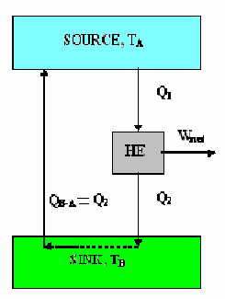







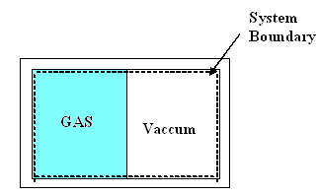

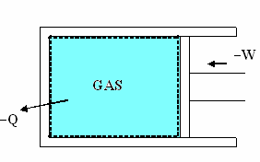

**INTIAL STATE**

**REVERSED PROCESS**

**The CARNOT cycle:**

To convert heat continuously into work, at least two thermal reservoirs are required, one will be a HTR (Heat source) which will supply heat to the heat engine and the other will be a low temperature reservoir LTR (sink) to which the heat rejected by the heat engine will flow.

Carnot was the first man to introduce the concept of reversible cycle. The CARNOT engine works between HTR & LTR.

High temp reservoir

CARNOT Engine

Low temperature reservoir

QH

QL

The Carnot cycle consists of an alternate series of two reversible isothermal and two reversible adiabatic processes. Since the processes in the cycle are all reversible the Carnot cycle as a whole is reversible.

*W*

The Carnot cycle is independent of the nature of the working substance and it can work with any substance like gas, vapour, electric cell etc.,

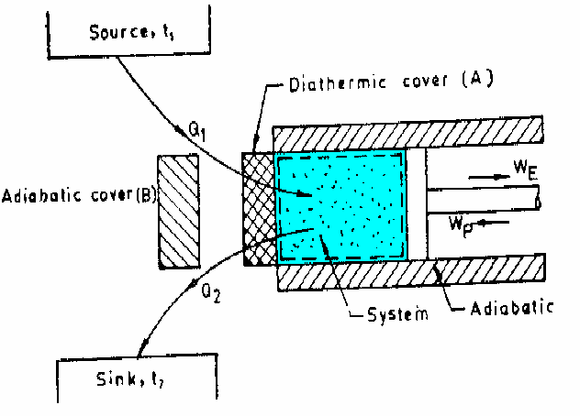

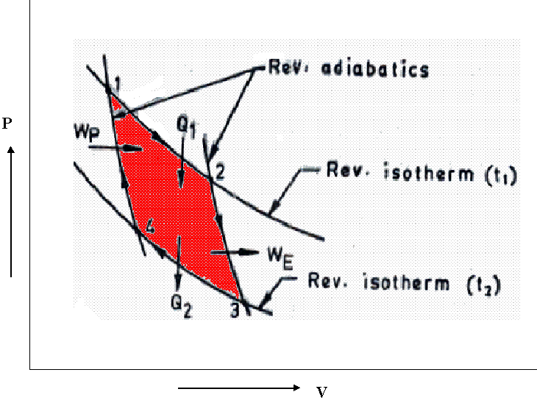

**CARNOT CYCLE ENGINE** **CARNOT CYCLE**

1) Process 1–2: Gas expands isothermally absorbing heat Q1 from the source at Temperature T1. Work done during this process is given by the area under 1 – 2 (W12)

2) Process 2–3: During this process cylinder is thermally isolated from the heat reservoir and the head is insulated by the piece of perfect insulator. Gas expands reversibly and adiabatically to temperature T2 to point 3. Work done is W23.

3) Process 3–4: Cylinder is in contact with the heat reservoir at T2. Gas is isothermally and reversibly compressed to point 4 rejecting an amount of heat Q2 to the sink. The work done on the W34.

4) Process 4–1: Cylinder is again isolated thermally from the thermal reservoir; gas is recompressed adiabatically and reversibly to point 1. The cycle is now complete. Work done is W41

The efficiency of the Carnot engine is given by,



From the above equation we can have the following conclusions.

**Even in an ideal cycle, it is impossible to convert all the energy received as heat from the source into mechanical work. We have to reject some of the energy as heat to a receiver at a lower temperature than the source (sink).**

The part of the heat which is converted into work is the available energy. The remainder of the heat which is to be rejected to the sink is unavailable energy.

Carnot cycle is the most efficient cycle, but it is impossible to carry out the Carnot cycle in real engines because of the following reasons.

* 1. To achieve isothermal process, the piston must move very slowly allowing heat interchange to keep temperature constant.
  2. To achieve adiabatic process the piston must move very fast so that the heat interchange is negligible due to very short time available.

The isothermal & adiabatic processes take place in the same stroke which means that for part of the stroke the piston must move very slowly and for remaining part, it must move very fast. But this is not possible.

Since Carnot cycle consists of reversible processes, it may be performed in either direction.



**Carnot heat pump with a gas**

|  |  |  |
| --- | --- | --- |
| Process 1 - 4 | Reversible adiabatic expansion | Temperature falls down from TH to TL |
|  |  |  |
| Process 4 - 3 | Reversible isothermal expansion | Temperature remains constant |
|  |  |  |
| Process 3 - 2 | Reversible adiabatic Compression | Temperature increases from TL to TH |
|  |  |  |
| Process 2 - 1 | Reversible isothermal Compression | Temperature remains constant |

COP of heat pump = 

COP of refrigerator = 

**Problems:**

A heat engine works on the Carnot cycle between temperature 900° C & 200° C. If the engine receives heat at the higher temperature at the rate of 60 kW, calculate the power of the engine.

TH = 900 + 273 = 1173 k

TL = 200 + 273 = 473 k



Also, 

∴ = 0.597 x 60 = 35.82 kW

**CARNOT theorem and corollary**

“An irreversible heat engine cannot have efficiency greater than a reversible one operating between the given two temperatures”.

That is ηreversible engine is maximum

This theorem can be proved by a process of reasoning.

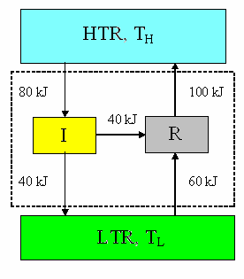

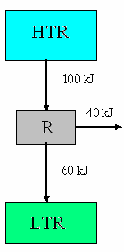

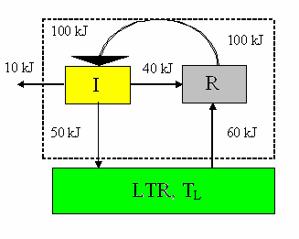

Fig. (c)

Fig. (a)

Fig. (b)

Imagine a reversible engine R as shown in fig (a). The thermal efficiency of the engine is therefore  Now if this engine is reversed 40 KJ of heat will be necessary to drive it, 60 KJ will be taken from LTR and 100 KJ will be discharged to the HTR.

In fig (b) an irreversible engine I is driving the reversible engine R.

Now for a moment, let us assume that the irreversible engine I is more efficient than the reversible engine R, say ηI = 50%, Then, since it takes 40 KJ to drive R, engine I will need to take  from HTR and it will reject 40 KJ to the LTR.

We now observe that, we have in fig (b) an isolated system where in the reversible engine R discharges 100-80 = 20 KJ more to the HTR than the irreversible engine I takes from the HTR more ever, the reversible engine R takes 60-40 = 20 KJ more from the cold reservoir than the irreversible engine I rejects to the LTR.

In other words, for the assumed condition that I is more efficient than R, we find that heat is being moved continuously from LTR to HTR without the external aid.

Instead of simply moving the heat as shown in fig (b), we could direct the flow of energy from the reversible engine directly into the irreversible engine, as in fig (c), whose efficiency is 50% would allow to drive engine R, and at the same time deliver 10 KJ of work to something outside of the system. This means the system exchanges heat with a single reservoir and delivers work.

These events have never been known to happen.

∴ We say that the assumption that I is more efficient than R is impossible.

∴ ηI ≤ ηR

**Corollary**

ηrev, engine = *f* (TH, TL)

All reversible engines have the same efficiency when working between the same two temperatures.

Consider two reversible engines **R1** and **R2**, operating between the two temperatures. If we imagine R1 driving R2 backward, then Carnot theorem states that.



If R2 drives R1 backward, then



It therefore follows that



If this were not so, the more efficient engine could be used to run the less efficient engine in the reverse direction and the net result would the transfer of heat from a body at low temperature to a high temperature body. This is impossible according to the second law.

Suppose **R1** & **R2** are two reversible engines working between the two same reservoirs as shown let us assume that **R1** is more efficient than **R2**.

By our assumption

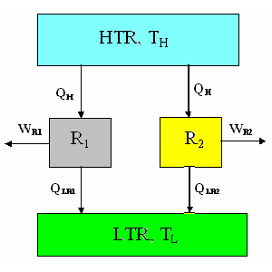



i.e., 

i.e., 

&  =  …………………. (1)

Now let engine **R2** be reversed so that it abstracts heat  from LTR at **TL** and delivers heat **QH** to HTR at **TH**. Since the heat required by **R1** is also **QH** we can replace the reservoir 1 by a conductor between **R1** & **R2**. This new combination would become a PMMK II because it would abstract a net amount of heat  from the single reservoir at TL and convert it completely into work.



But this is impossible; hence the corollary must be true.

**The Thermodynamics Temperature Scale**

Zeroth law provides a basis for temperature measurement, but it has some short comings, since the measurement of temperature depends on the thermometric property of a particulars substance and on the mode of working of the thermometer.

We know that the η of a reversible engine operating between two thermal reservoirs at different temperatures depends only on the temperatures of the reservoir and is independent of the nature of the working fluid.

With this principle lord Kelvin decided a temperature scale that is independent of the thermometric property of the working substance and this is the Kelvin temperature scale or thermodynamic temperature scale or absolute temperature scale.

The concept of this temperature scale may be developed as follows.



Where, T → absolute temperature

There are many functional relations possible to relate  &  to  &, which will serve to define the absolute scale. the relation that has been selected for the thermodynamic scale of temperature is



The Carnot efficiency may be expressed as



This means that if  of a Carnot cycle operating between two given constant temperature reservoirs is known, the ratio of the to absolute temperature is also known, in order to assign values of absolute temperature, however one other relation between TL and TH must be known.

**Construction of Kevin temperature scale**

Consider a series of reversible engines operating between thermal temperature reservoirs in the following way. R1 absorbs an amount of heat Q1 from a thermal reservoir at T1 and rejects heat Q2 to a thermal reservoir at T2. R2 absorbs an amount of heat Q2 from the reservoir at T2 and rejects Q3 to a reservoir at T3 and so on. The temperatures are selected in such a way that the work done by each engine is the same i.e.,

Thermal reservoir at T1

R1

Thermal reservoir at T2

Q1

Q2



TL

Thermal reservoir at T3

R2

Q2



Q3



Or

(Q1 – Q2) = (Q2 – Q3) = (Q3 – Q4) = ----- = W (1)

From the definition of Kelvin temperature scale we have



∴

On solving equations (1) & (2) we get

T1 – T2 = T2 – T3 = T3 – T4 = - - - - - - (3)

From this equations we conclude that the reversible engines operating in series in this way as shown in Fig develops equal work when the temperature difference across them are equal.

Now a decision to be made on the magnitude of the degree of the Kelvin temperature scale. This is usually done by choosing the steam point and the ice point at one atmosphere as the reference temperatures. As the difference between these points s is 100 degrees, we can write

Ts - Ti = 100 ………….. (4)

Steam pt ice pt

On the other equation involving Ts & Ti can be derived experimentally by finding out the η of a reversible engine operating between the steam point and the ice point. The efficiency η = 26.80%

Hence,  

Solving (4) & (5), we get

Ts = 373:15 K, Ti = 273.15 K

K = °C + 273.15

∴ Relationship between K & °C is given by

**Problems** (on second Law of thermodynamics)

**Problem 1.** An engineer claims to have developed an engine which develops 3.4 kW while consuming 0.44 Kg of fuel of calorific value of calorific value of 41870 kJ / kg in one hour. The maximum and minimum temperatures recorded in the cycle are 1400° C & 350° C respectively is the claim of the engineer genuine (Sept./Oct. 1996)

Solution:

Temperature of source, TH = 1400° C = 1673 K

Temperature of sink, TL = 350° C = 673 K

We know that the thermal efficiency of the CARNOT cycle is the maximum between the specified temperature limits and is given as.



i.e., 

= 62.8%

The thermal efficiency of the engine developed by the engineer is given as



We have, 



& 

Since  Engineer claim is not genuine **Answer**

**Problem 2.** Two Carnot engines A and B are connected in series between two thermal reservoirs maintained at 100 k and 100 k respectively. Engine A receives 1680 kJ of heat from the high temperature reservoir and rejects heat to Carnot engine B. Engine B takes in the heat rejected by engine A and rejects heat to the low temperature reservoir. If engines A and B have equal thermal efficiencies determine (1) The heat rejected by engine B (2) The temperature at which heat is rejected by engine A and (3) The work done during the process by engines A and B respectively.

Solution:

QHA = 1680 KJ

High temp reservoir TH = 1000 K

HE A

Low temperature reservoir TL = 100 K

QHA = 1680 KJ

QLA = QHB

WA = QHA - QLA

HE B

QLB

WB = QHB - QLB



We have,





TL = THB





i) Given 

∴ 

 

i.e., 

= 100000 K2

[∴ TLA = THB = 316.23 K, i.e., the temperature at which heat is rejected by engine A]

ii) We have also



= 0.684 or 68.4%

The heat rejected by engine B





We have,



i.e., 

= 531.27 KJ = QHB

Substituting this in (1) we get  Ans.

iii) Work done

WA = QHA – QLA = 1680 – 531.27 = 1148.73 KJ

WB = QHB – QLB = 531.27 – 168 = 363.27 KJ

**Problem 3.** A reversible refrigerator operates between 35° C and -12° C. If the heat rejected to reservoir is 1.3 kW, determine the rate at which to heat is leaking into the refrigerator.

Solutions: Reversible refrigerator

TH = 35° C = 308 K

TL = -12° C = 261 K

(COP) Ref = 

 ( It is a reversible refrigerator)

TH = 308 K





Ref

i.e, 



= 5.553

TL = 261 K

i.e, 

i.e., 

i.e.,  = 1.102 kW Ans.

**Problem 4.** A reversible power cycle is used to drive heat pump cycle. The power cycle takes in Q1 heat units at T1 K and rejects Q2 at T2 K. The heat pump abstract Q4 from the sink at T4 k and discharges Q3 units of heat to a reservoir at T3 K. Develop an expression for the ratio Q4 / Q1 in terms of the four temperatures

Solution:-

Source T1 K

HE

Sink

T2 K







HP

Source T3 K

Sink

T4 K





We have

For reversible power cycle,



For reversible heat pump cycle,

(COP) H.P 

Multiply (1) by (2), we get



Considering LHS,

Since 







On substitution in the above equation

 = 

i.e., 





 Ans

**Problem 5.** A Heat engine is used to drive a heat pump. The heat transfers from the heat engine and from the heat pump are used to heat the water circulating through the radiators of a building. The efficiency of the heat engine is 27% and the coefficient performance of heat pump is 4. Evaluate the ratio of heat transfer to the circulating water to the heat transfer to the heat engine.

Solution:-

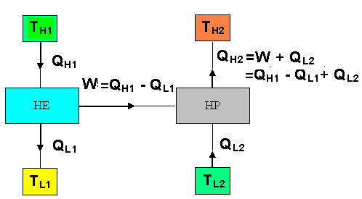



(COP)HP = 4

We have

Heat rejected from heat engine = 

Heat transfer from heat pump = 

Heat transfer from circulating water = 

∴ The ratio of heat transfer to the circulating water to the heat transfer to the engine

= 

We also have,





We have from (2),



From (3),





Substituting in equation (1), We obtain

 Ans.

**Problem 6.** It is proposed to construct a refrigeration plant for a cold storage to be maintained at - 3°C. The ambient temperature is 27°C. If 5 x 106 kJ /hr of energy has to be continuously removed from the cold storage, calculate the maximum power required to run.

**Problem 7.** There are three reservoirs at temperatures of 827°C, 127°C and 27°C parallel. A reversible heat engine operates between 827°C and 127°C and a reversible refrigerator operates between 27°C and 127°C respectively 502 kJ of heat are extracted from the reservoir at 827°C by the heat engine and 251 kJ of heat are abstracted by the refrigerator from the reservoir at 27°C. Find the net amount of heat delivered to the reservoir at 127°C.

Can the heat engine drive the refrigerator and still deliver some net amount of work? If so how much?

Solutions: Given: Reversible heat engine and refrigerator

T1 = 827°C

= 1100k

HE

T2 = 127°C

= 400k

Ref

T3 = 27°C

= 300k

251 kJ

QHR

QLE

QHE

502 kJ

QLR

 

For heat engine 

For Refrigerator 

We have 

Also,  = 319.27 kJ

& 

Also 



i.e.,  = 334.67 kJ

For HE, 

Net amount of Heat delivered

 = 182.73 + 334.67 = 517.4 kJ Ans.

 i.e. work required to drive the refrigerator

 = 83.67 kJ

Since  Heat engine drives the refrigerator and still deliver some net amount of work

i.e,  = 319.27 – 83.67 = 235.6 kJ

**THE THERMODYNAMIC TEMPERATURE SCALE**

A Temperature scale that is independent of the properties of the substances that are used to measure temperature is called a Thermodynamic scale of temperature. It can be defined with the help of reversible heat engines.

The thermal efficiency of a reversible engine is given by



i.e., 

Also, 

If some functional relationship is assigned between TH, TL and QH, QL equation (2) then becomes the definition of a temperature scale.

This functional form of can be developed by considering the three reversible heat engines as shown.

Engines R1 & R2 can be combined into one reversible engine operating between the same reservoirs as engine R3 and thus this combined engine will have the same efficiency as engine R3

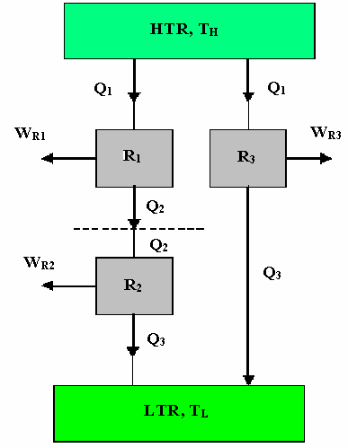

Using equation (2) we can write for engines R1, R2 and R3 respectively.



and 

Also  can be expressed as



i.e., 

From the above equation we see that, the left hand side is a function of T1 and T3, the right hand side too must be a function of T1 and T3, only and not T2. That is the value of the product on R.H.S is independent of T2. To satisfy this condition, the function  must have the following form:

 & 

So that,



For a reversible heat engine operating between two reservoirs at TH & TL, equation (3) can be written as:



This is the only condition that the second law stipulates on the ratio of heat flows to and from the reversible heat engines. Since the function φ (T) is completely arbitrary, several values of it will satisfy equation (4). Lord Kelvin first proposed taking φ (T) = T to define thermodynamic temperature scale as:



This scale is called the Kelvin scale and the temperatures on this scale are called absolute temperatures.

With equation (5) the thermodynamic scale is not completely defined, since it gives only a ratio of the absolute temperatures. The triple point of water is assigned the value 273.15 k. The magnitude of a Kelvin is defined as 1/273.15 of the temperature interval between absolute zero and triple point temperature of water. The magnitudes of temperature units on the Kelvin and Celsius scales are identical (1k = 1°C) the temperature on the scales are related by a constant 273.15 (the temperature of the ice point) as:

T (°C) = T (k) – 273.15 *

**Additional Problems:**

**Problem 8.** There are two ways of increasing the efficiency of a Carnot heat engine:

i) Lowering the temperature T2 of the low temperature reservoir by ∆T, while keeping the temperature T1 of the high temperature reservoir a constant.

ii) Increasing the temperature T1 by ∆T, while keeping the temperature T2 a constant. Which is more effective? Prove your answer.

**Problem 9.** An inventor claims that his engine has the following:

Specifications

Heating value of the fuel: 74500 kJ / kg, Temperature limits: 750 0 C and 25 0C

Power developed: 75 kW,

Fuel burned: 0.07 kg / min

State whether the claim is valid or not.

**Problem 11.** A Carnot refrigerator consumes 200 W of power in summer when the ambient atmosphere is 40 0C. The rate of energy leak into the refrigerator is estimated at 20 W per degree Celsius temperature difference between the ambient atmosphere and the cold space of the refrigerator. If the refrigerator is continuously operated, determine the temperature at which the cold space is maintained.

**Problem 12.**  Direct heat engine operating between two reservoirs at 327 0C and 27 0C drives a refrigerator operating between 27 0C and 13 0C. The efficiency of the heat engine and the COP of the refrigerator are each 70% of their maximum values. The heat transferred to the direct heat engine is 500 kJ. The net heat rejected by the engine and the refrigerator to the reservoir at 27 0C is 400 kJ. Find the net work output of the engine-refrigerator combination. Draw the schematic representation.

**Problem 13.**  A reversible heat engine operates between two reservoirs at constant temperature of 160 0C and 20 0C. The work output from the engine is 15 kJ / sec. Determine: i) Efficiency of the cycle ii) Heat transfer from the reservoir at 160 0C iii) heat rejected to the reservoir at 20 0C. If the engine is reversed and operates as a heat pump between the same two reservoirs, determine the COP of the heat pump & the power required when the heat transfer from the reservoir at 20 0C is 300 kJ / min.

**Problem 14.**  A cyclic heat engine operates between a source temperature of 800 0 C and a sink temperature of 30 0C. What is the least rate of heat rejection per kW net output of the engine?

**Problem 15.**  Areversible heat engine operates with two environments. In the first it draws 12000 kW from a source at 400 0C and in the second it draws 25000 kW from a source at 100 0C. In both the operations the engine rejects heat to a thermal sink at 20 0C. Determine the operation in which the heat engine delivers more power.